Why am I being given this information?
Our research team at King’s College London (KCL) are giving you this information because you have completed our first eligibility screening for our research (called “Online peer support in long-term conditions: A feasibility randomised controlled trial”). As the information sheet stated, there will be a wait period between when we first talk with you and when we will be ready to begin the trial. This information tells you why we have the wait period and what to expect next.
What is the wait period for, and how long will it be?
The wait period is the time between when we first assess the eligibility of someone who is interested in our research and when we have recruited enough people (approximately 150 people) to begin the research. As the new intervention that we are trialling involves an online community, it is essential that we have enough people enrolled to allow a community to form and discussions to emerge naturally.
The length of the wait period will vary for each person, dependent on how many people have completed a screening before you, how many more people we need to screen, and how quickly we can recruit.
If you know of anyone who might be interested in participating in our research, encourage them to contact us. If you have any questions, please do not hesitate to contact us:
Hannah Grace Jones (Research Assistant at KCL) Email: commonground@kcl.ac.uk  Phone or video call available at request | Dr Grace Lavelle (Research Fellow at KCL)  Email: commonground@kcl.ac.uk  Phone or video call available at request.

What happens next?
Once we have recruited enough people, we will ask you to complete the second eligibility screening. This second eligibility screening is to understand whether there have been any changes in your mental health or mental health care.
If you are still suitable to participate in our research, you will be told whether you are able to take part in our research trial (and be randomly assigned to either the new intervention group or the control NHS “Mental Health” webpages group) or in the community engagement study (access to the new peer support intervention). At this time, you will be provided with more information to read before you make your decision if you still want to take part in our research. Please be aware that our research team cannot choose or change which research you are eligible to participate in.
The timeline below shows what has happened so far, and the next stages. To view the image enlarged, please select the PDF “Participant timeline: The wait period – what has happened and what happens next” from the previous page.
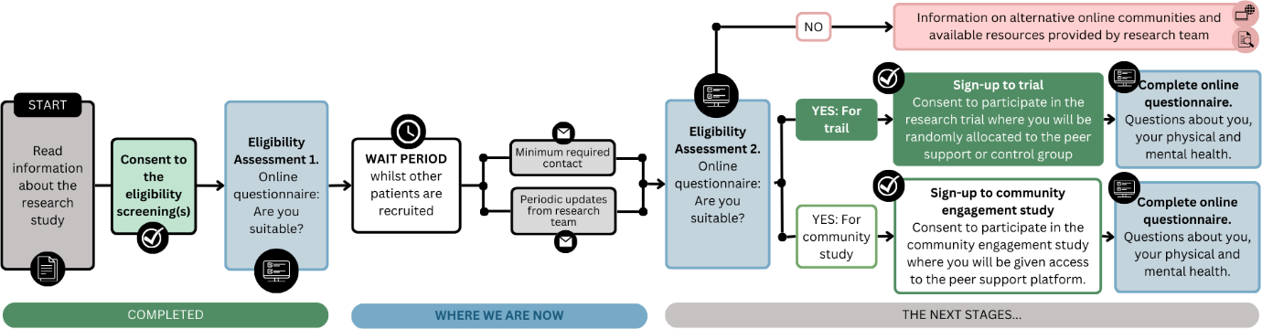
What updates will I get during the wait period?
Throughout the wait period you will be able to check our progress in recruitment and our estimation of when we will complete the second eligibility screenings on the ‘CommonGround live recruitment tracker’ on the previous page.
Our research team will also send periodic updates about the research and our recruitment progress to let you know when you can complete your second eligibility screening. If you do not wish to receive these email updates, please let our research team know via email: commonground@kcl.ac.uk. If you choose to opt-out of these emails, you will only be contacted when it is time to complete your second eligibility screening, or if any urgent study updates are required or in the unlikely event of an emergency.
