Thank you for your time. Unfortunately, you are unable to take part in our research at this time. Please see the below information. If you have any questions, please email us at commonground@kcl.ac.uk.
Why am I being given this information?
Our research team at King’s College London are giving you this information because you expressed interest in participating in our research (called “Online peer support in long-term conditions: A feasibility randomised controlled trial”) and completed the eligibility screening(s).
You are receiving this leaflet as unfortunately you are not suitable to be involved in this current trial. We are sorry if this is not the decision you were hoping to hear. This information leaflet explains why it is important for us to only include people who meet our criteria and provides you with some further information on other support services that are available, should you wish to seek further support.
Why can’t I participate?
When we are creating and testing new interventions to help improve people’s mental health, it is important that we test the intervention with the specific group of people that we are hoping to help. In the current research, we are interested in developing a peer support and educational platform for people living with long-term conditions who also have low level symptoms of depression. One of the purposes of our research is to see if a platform like this may be able to prevent people with long-term conditions developing more severe depressive symptoms.
This means that anyone who is not living with a long-term condition or is currently experiencing severe depressive symptoms (as measured during our eligibility screenings), and/or those people with a specific diagnosed mental health condition (such as bipolar, psychosis, post-traumatic stress disorder, and/or schizophrenia and/or dementia) are not able to take part in this research study. Furthermore, as we are exploring a potentially new intervention, this research is also not suitable for anyone currently engaging with or receiving treatment for a mental health condition as this may influence the results that we find.
We also need all those participating to be over 18 years of age and be able to freely consent to taking part in the study. Finally, as this is a trial of an online, interactive peer support platform access to internet is also required, as is having a sufficient level of English to be able to engage and interact with the platform.
What is available for me?
If you need someone to talk to or are seeking extra support, you can talk with the Samaritans (call 116 123) or text SHOUT (text SHOUT to 85258). Both organisations offer free anonymous, confidential, one-to-one support via the telephone or text, and are available 24/7 for 365 days per year. If you feel unsafe or require emergency care, please call 999 or visit your nearest A&E immediately. For urgent but non-emergency medical advice, dial NHS 111.
If you want to join an anonymous online community, the charity MIND run ‘Side by Side’. You can post, comment, and private message with other users. It is free, anonymous, and available 24/7. For further information please visit: www.sidebyside.mind.org.uk.
The Samaritans also have a self-help app on their webpage that allows you to keep track of how you are feeling and get recommendations of different ways to help you cope and stay safe in a potential crisis. There are activities on problem solving, accepting change, and relaxation that you might find useful. You can access the Samaritans self-help app here: https://selfhelp.samaritans.org/.
The NHS have a series of webpages to find information and support for your mental health (www.nhs.uk/mental-health). The self-help webpages include tips and support, activities and tools to help you cope with your mental health, and information on finding urgent help. You can access the self-help webpages here: www.nhs.uk/mental-health/self-help.
What if I want to be involved in more research?
Once again, we are sorry that you are not suitable to take part in this particular research study. If you are interested in potential future research opportunities, please do not hesitate to contact our research team (contact details below) who will be more than happy to guide you to other potential research opportunities that may be more suitable for you to take part in. They will add your contact details to a database, and you may be contacted by researchers in the future. 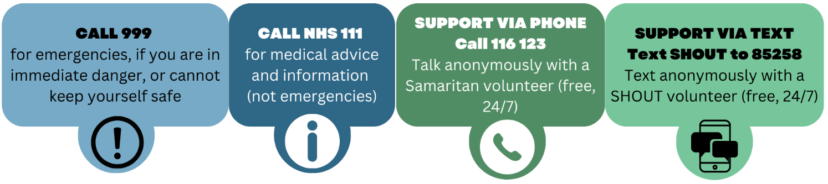
Hannah Grace Jones (Research Assistant at KCL)  Email: commonground@kcl.ac.uk  Phone or video call available upon request | Dr Grace Lavelle (Research Fellow at KCL)  Email: commonground@kcl.ac.uk  Phone or video call available upon request
Any questions? Contact us:
